MIDI THRU port circuit for Casio SK keyboards with HIGHLY LIQUID's MIDI IN kit installed.

**************************************************************************************

This circuit will add MIDI thru ports to any MIDI IN circuit fitted to sk1/5/8's, such as HIGHLY LIQUID's MIDI kit.

NOTE: You must have this MIDI IN kit installed first for this MIDI THRU to be of any use.

The plans are actually for a stand alone MIDI 1 in 4 out thru box that can be used for any MIDI device, but it is easy to fit the circuit inside your Casio Sk sampler, and it will give you up to 4 MIDI thru ports. You only have to hook up 1 thru port if you only want one, or don't have the room on your SK's back panel for any more.

Procedure:

Buy or make the MIDI IN Kit for your SK first, such as:

http://highlyliquid.com/kits/skm/

- Install it and test it to confirm it works.

Now:

Build the MIDI THRU circuit as per the plans, as a stand alone circuit first, NOT inside the SK, to start with. Run it off a 9V DC plug pack as per the plans.

Test the circuit to make sure it works: - Plug any master keyboard with MIDI out into the MIDI IN of the circuit. Now plug the Casio SK keyboard that has a HIGHLY LIQUID's MIDI IN kit installed into one of the 4 outs on the MIDI thru circuit. Switch everything on, choose a sound on the casio. Play some notes on the master keyboard, if your MIDI channels are set correctly, you should hear your SK playing as you play your master keyboard. The MIDI light on the MIDI thru circuit should also flash as you play. This has now confirmed that the circuit is working.

Next:

Open up your casio, and unsolder the wires from the MIDI IN socket of the HIGHLY LIQUID's MIDI IN kit circuit, freeing the wires from it. Solder the MIDI IN wires of the MIDI THRU's circuit to this socket.

Now, solder the loose leads of the HIGHLY LIQUID's MIDI IN kit to one of the 4 MIDI out's of the MIDI THRU's circuit. Now, test the connections - plug in a master keyboard into the IN of the Casio's THRU circuit, switch everything on. Play the master keyboard, test that the casio is responding. If OK, switch off everything.

Mount the MIDI THRU circuit board securely in a suitable place inside the casio.
Mount a MIDI THRU socket in the casing in a convenient place for a THRU port. Hook up one of the 3 spare MIDI THRU's wires of the circuit to the socket. You could have up to 3 of these installed in the same way, if you wish. Again, hook all the keyboards up and test that the Casio still responds. If OK, now plug in another MIDI instrument, from the Casio's MIDI THRU out port to its MIDI IN port, set all the MIDI channels the same on all of the keyboards. Play the master keyboard. You should now hear the Casio playing, and now also the other keyboard or instrument.

Now hook up the MIDI THRU circuit to run off the casio's power, instead of the THRU circuit's plug pack:

Unsolder the 9V plug pack wires off the MIDI THRU circuit and remove the plug pack. Solder one end of a wire to the +V input of the THRU circuit. Solder it's other end to the +V point as seen in the picture below, on the SK circuit board.

Do the same for the Ground (GND, or 0V) wire, connecting it as seen in the picture:
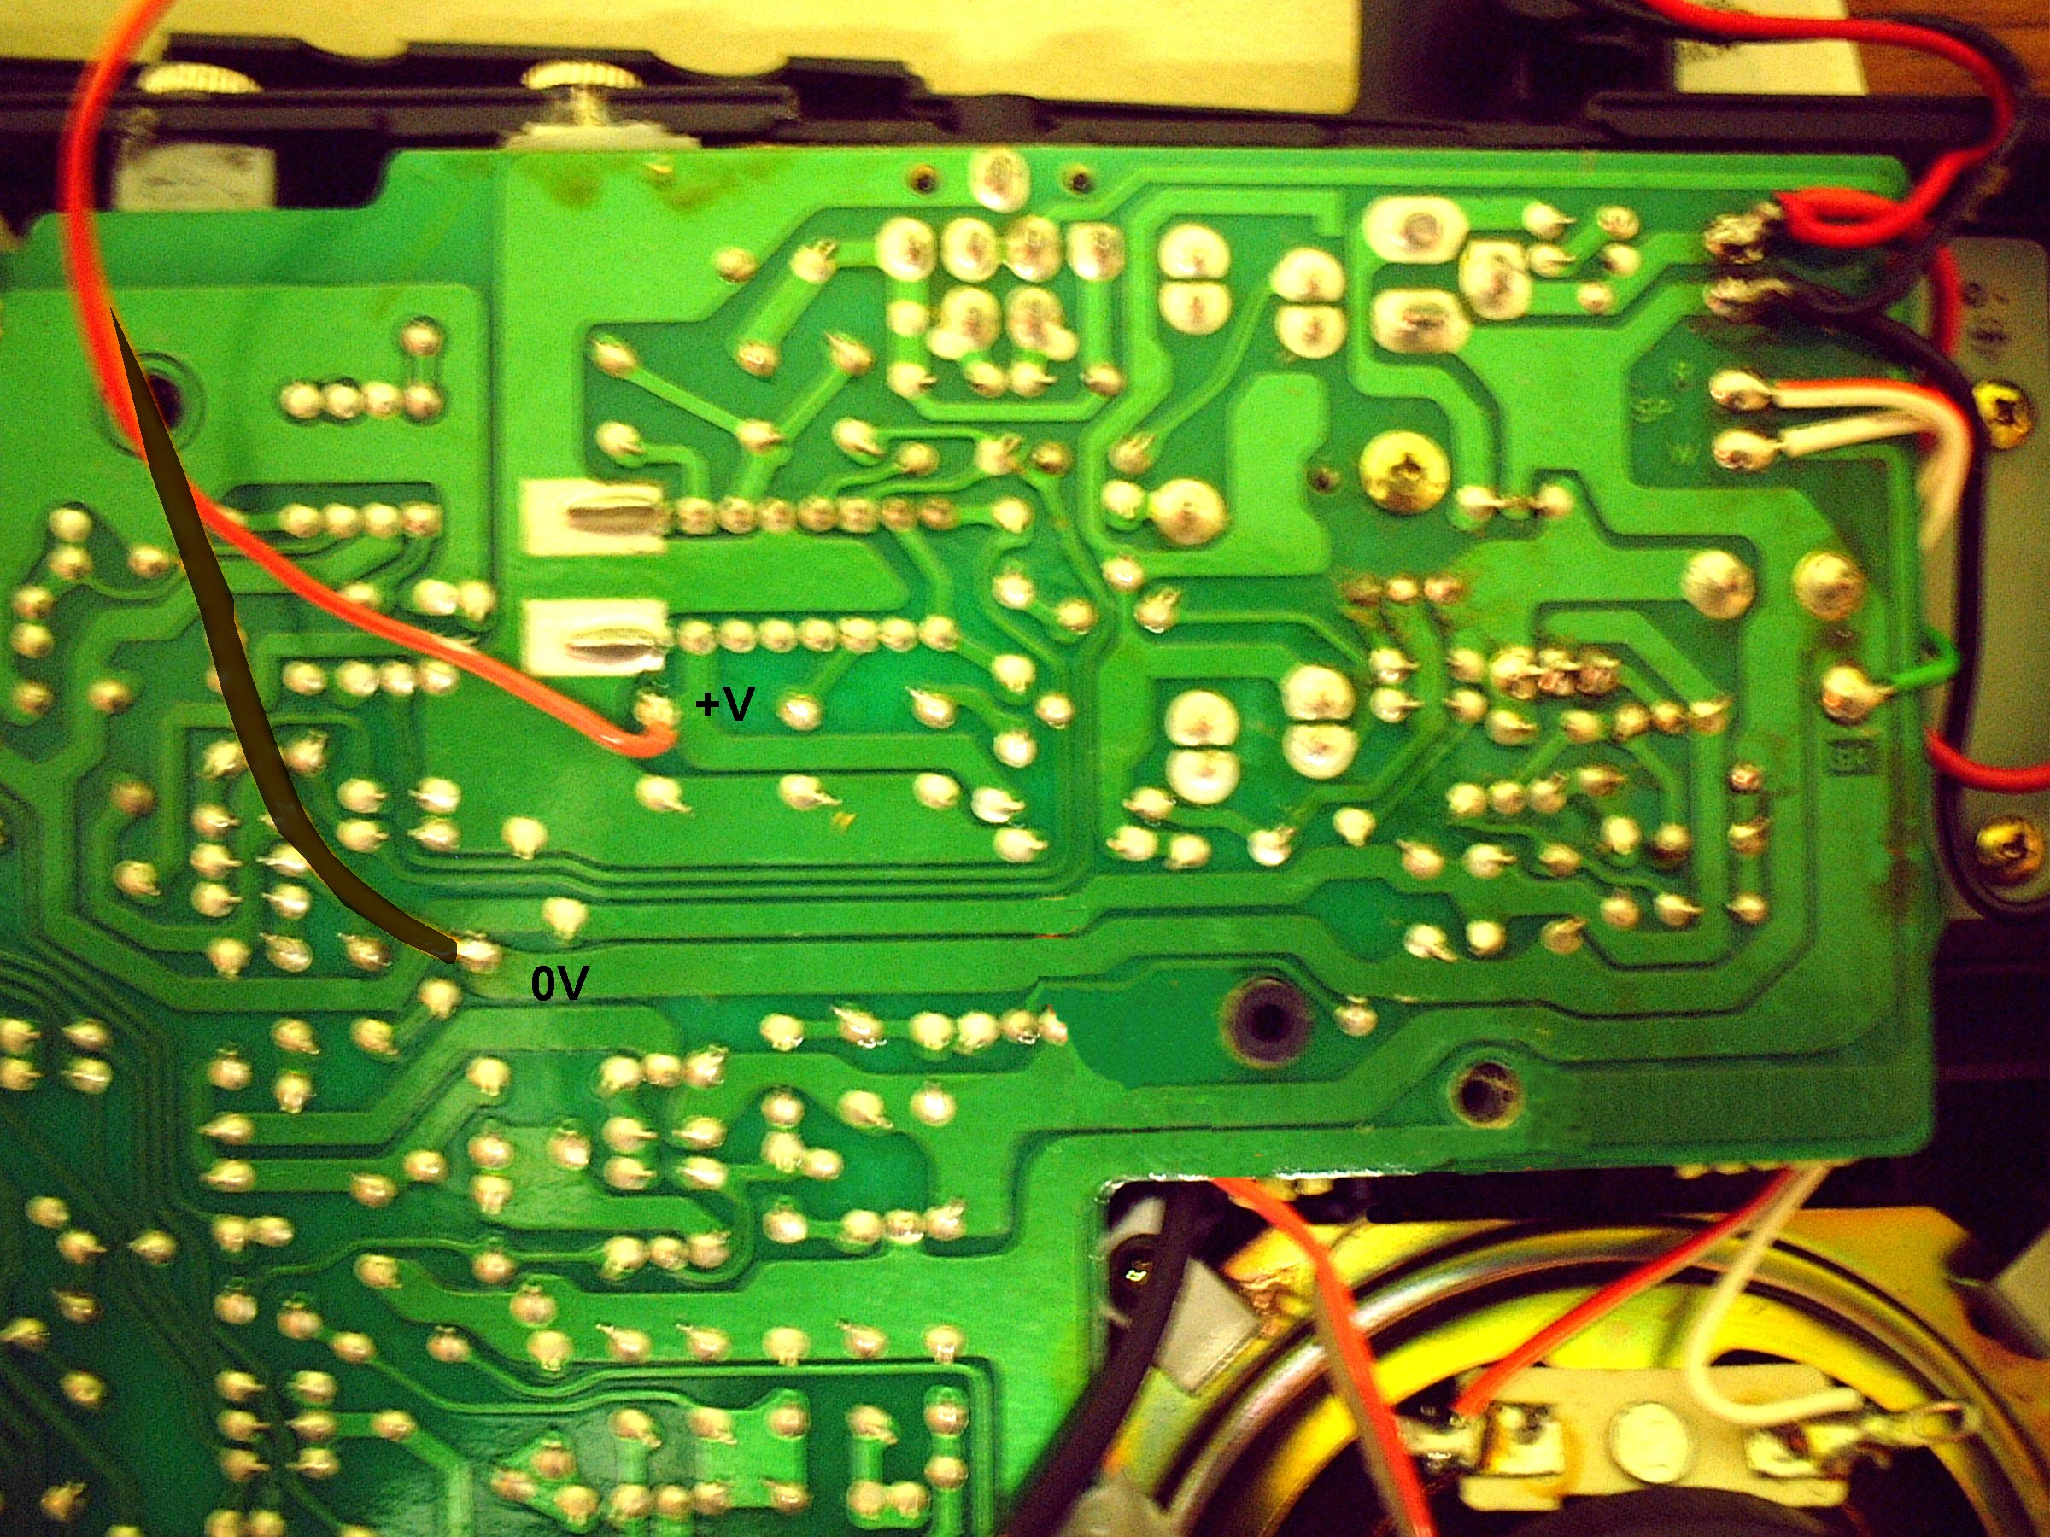

Now switch on the Casio. If you still have the LED's connected to the MIDI THRU circuit, you should see its POWER LED light up. This confirms that the circuit is powering off the Casio's power. Connect the master keyboard to the MIDI IN of the casio. Play the master keyboard. If all is ok, you should hear the casio play, and see the MIDI IN light of the circuit flashing. Connect a keyboard or instrument to the casio MIDI THRU port, and confirm again that all is working. If it is, congratulations, you've now made a MIDI THRU port for your Casio!!.

PLEASE NOTE:

This circuit is NOT a "MIDI OUT" port - it will not enable you to use the Casio SK as a MASTER keyboard and control other keyboards with it - it only "echoes" or passes on the MIDI data that it receives at its MIDI IN port to its THRU ports.

What it WILL enable you to do is to connect a MIDI sequencer, keyboard or computer, to the Casio, and then hook up a drum machine, synth or module to the casio's thru (and, if you connected up the other 2 spare lines of the circuit with sockets, 2 more instruments!!)

Cheers, Graham

P.S. - HIGHLY LIQUID's MIDI kit has the problem of being permanently switched on, due to the place specified in its instructions to solder the power leads. This will cause the batteries in the Casio to drain quickly and lose its sample memory.

Because it needs +5V to power it, you cannot simply hook it up to the same place as the MIDI THRU circuit to power it, because at that place, the Casio supplies +10V, and may cause damage to the optocoupler in it.

However, the MIDI THRU circuit has its own +5V regulator on the circuitboard, and so you can supply HIGHLY LIQUID's MIDI circuit with +5V directly from the MIDI THRU board. See the MIDI IN circuit document for instructions on how to do this.

